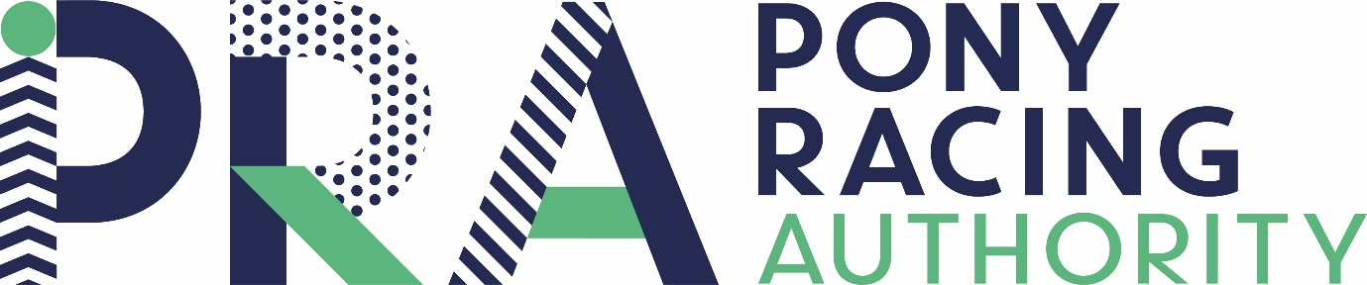

THE PRA CERTIFICATE
This award is available to all Pony Racers. Tasks are to be set by parents/guardians over the coming weeks.
These tasks are to be set by the jockey’s parents/guardians. They are not restricted to pony racing directly.
Please email verity@ponyracingauthority.co.uk with any queries and, of course, the name and any special details of your jockey’s achievements on completion – this will be at the end of the ‘lockdown’ period.
Here are some ideas to get you started:
- Cleaning out and filling the water buckets daily
- Skipping out
- Sweeping the yard am and pm
- Poo picking in the field
- Keep fit
- Putting away clean clothes and ensuring dirty ones are in the right place to be washed
- Tidying shoes by the door
- Helping to do the washing up
- Finishing school work on time

THE PRA CERTIFICATE
The following have been set for Pony Racing Jockey ______________ to complete.

Tasks set:
- _______________________________
- _______________________________
- _______________________________
- _______________________________
- _______________________________
- _______________________________
- _______________________________
- _______________________________
- _______________________________
- _______________________________

